**USER MANUAL**

1. 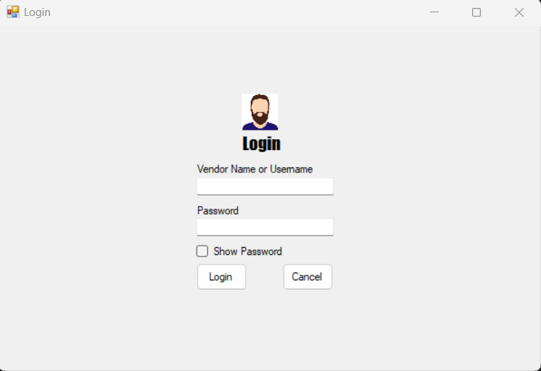The first step upon opening the software is for the vendor, to login their credentials.
2. In the main menu, there are six, (6) buttons to choose from. All of these are the main features of the software: **Add Product, View Sales, Add Customer, Excel Viewer, Logout and Vendors.**

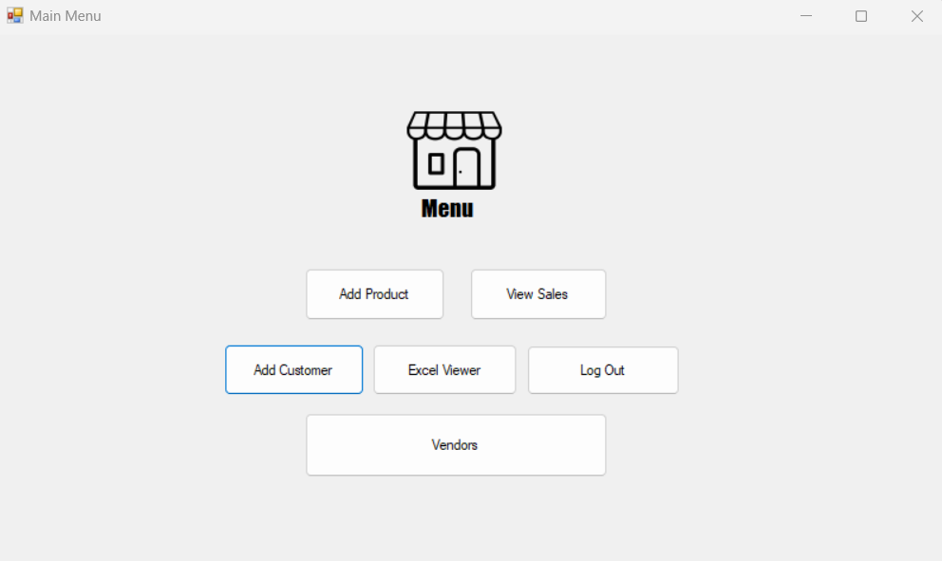

* **Add product**:

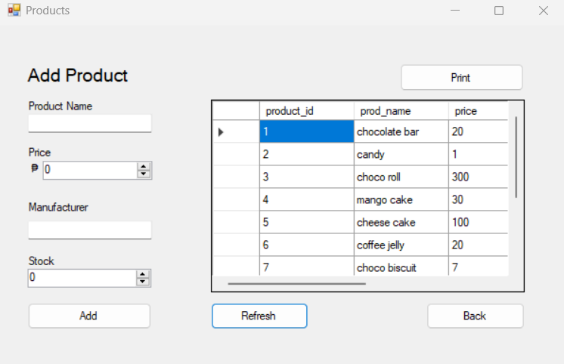

* **Add** button: From the name of the button itself, this adds products in the inventory and will later show when you tap the **refresh** button. Just add the product name, price, name of manufacturer, and the stock quantity.
* **Refresh** button: This just loads the data grid, or the inventory table to make it visible.
* **Print** button: This button exports the content of the table into a .xlsx file format that can be printable.
* **Back** button: This button’s function just goes back to the main page of the program.
* **View Sales**:

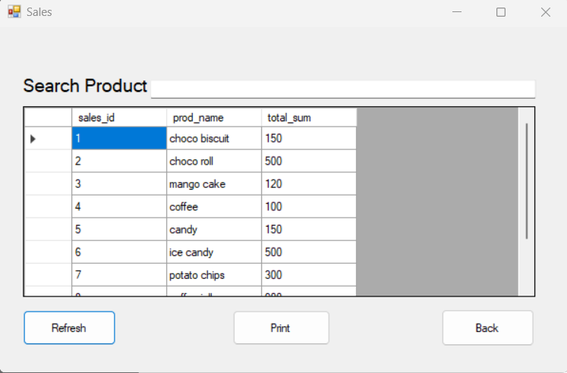

* **Refresh** button – refreshes to show or load the product inventory inside the table
* **Search** bar – searches for the product based on name and sales id and the table filters out the result
* **Print** button – exports table to excel .xls file
* **Back** button – redirects to main menu
* **Add Customer:**

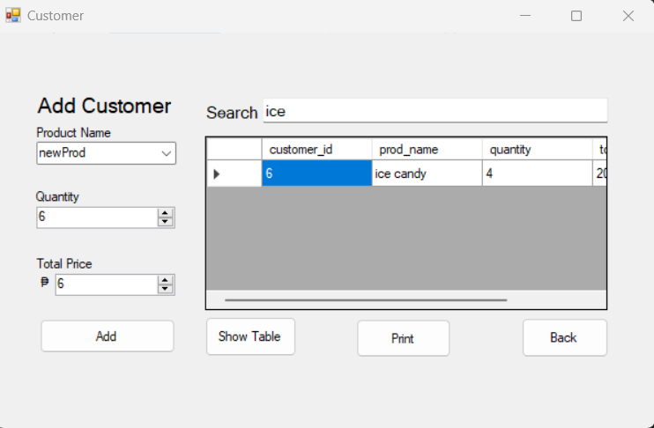

* **Add** button: This adds customer orders in the table and will later show when you tap the **Show Table** button.
* **Show Table** button: This just loads the data grid, or the inventory table to make it visible.
* **Print** button: This button exports the content of the table into a .xlsx file format that can be printable.
* **Back** button: This button’s function just goes back to the main page of the program.
* 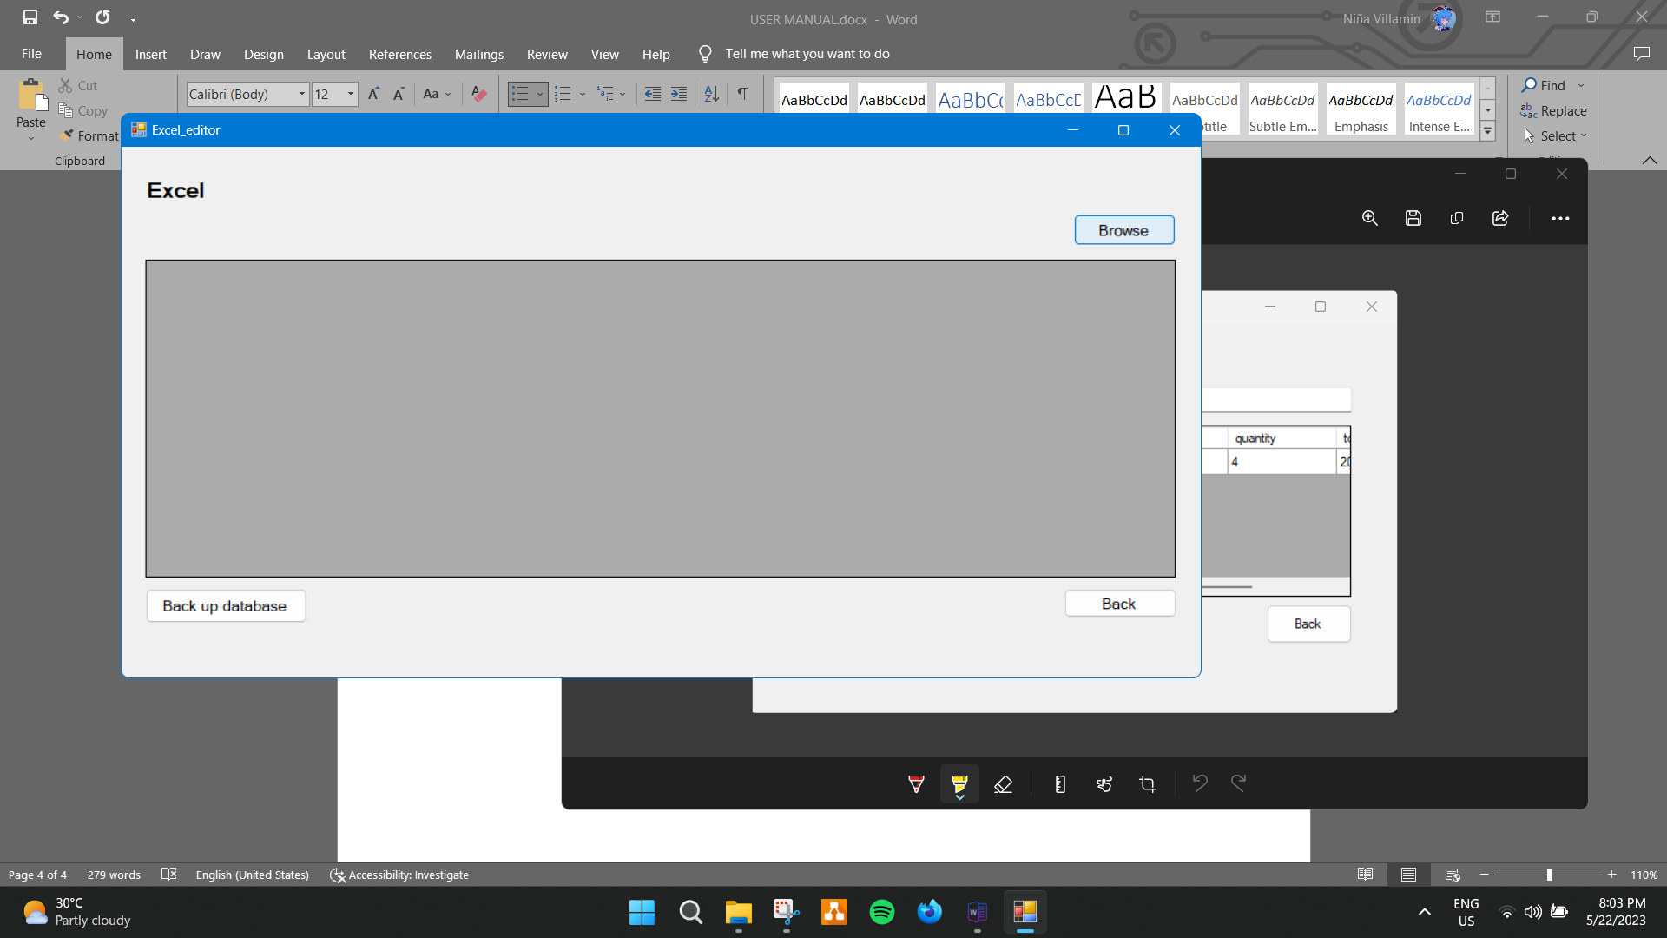**Excel viewer:**
* **Browse** button: Gets a .csv or .xls file to load to the screen

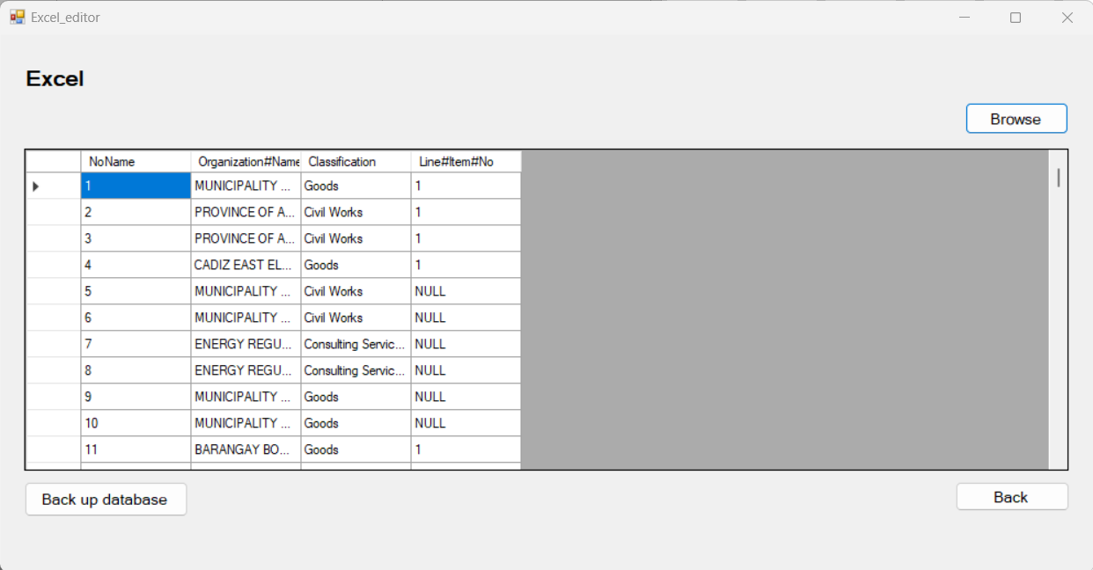

* **Back up database** button: Locates a .bat file containing the mysql dump code to backup the database from the datagrid.
* **Back** button: This button’s function just goes back to the main page of the program.

* **Vendors:**

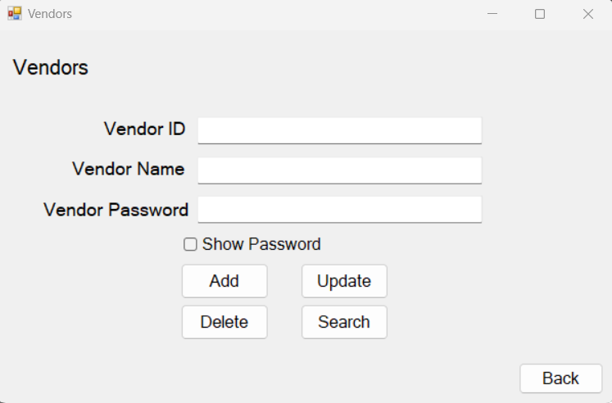

* **Search** button: The user must first search for the name in order to **Delete,** and **Update** the name, id and password
* **Add** button: This adds new vendor inside the database
* **Update** button: Updates the data
* **Delete** button: Deletes the data from the database
* **Back** button: This button’s function just goes back to the main page of the program.
* **Logout –** redirects to the login page.